

## Topic: Browser Requirements

Have you encountered issues when accessing theSource using your browser? If so, reconsider the browser that you’re using!

The preferred browser when using theSource is Google Chrome version 50.0 or higher.

To check your Google Chrome version, open a Google Chrome page and:

1. Select the three dots in the upper right-hand corner.
2. Select **Help**.
3. Select **About Google Chrome**.

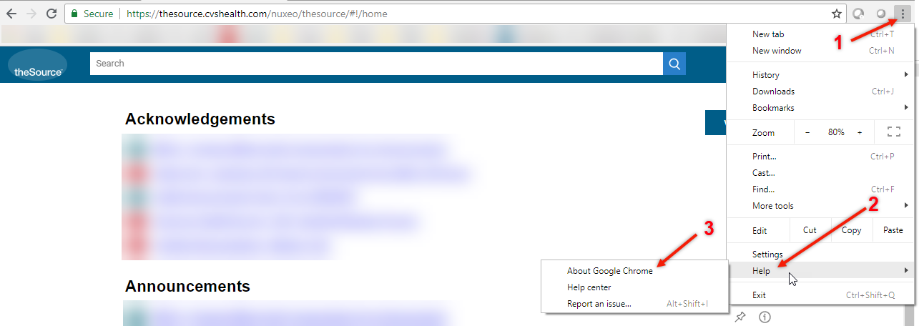

**Result:** A tab opens with information, including the version of your browser:

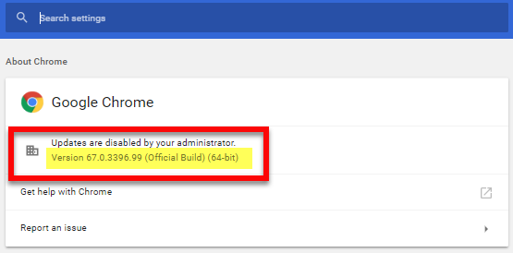

 Your next challenge on the quest to becoming a Certified theSource Wizard is to ensure that you’re using Google Chrome 50.0 or higher when accessing theSource.

Additional resources:

Become a Certified theSource Wizard: Index

Not to Be Reproduced or Disclosed to Others without Prior Written Approval

**ELECTRONIC DATA = OFFICIAL VERSION / PAPER COPY = INFORMATIONAL ONLY**